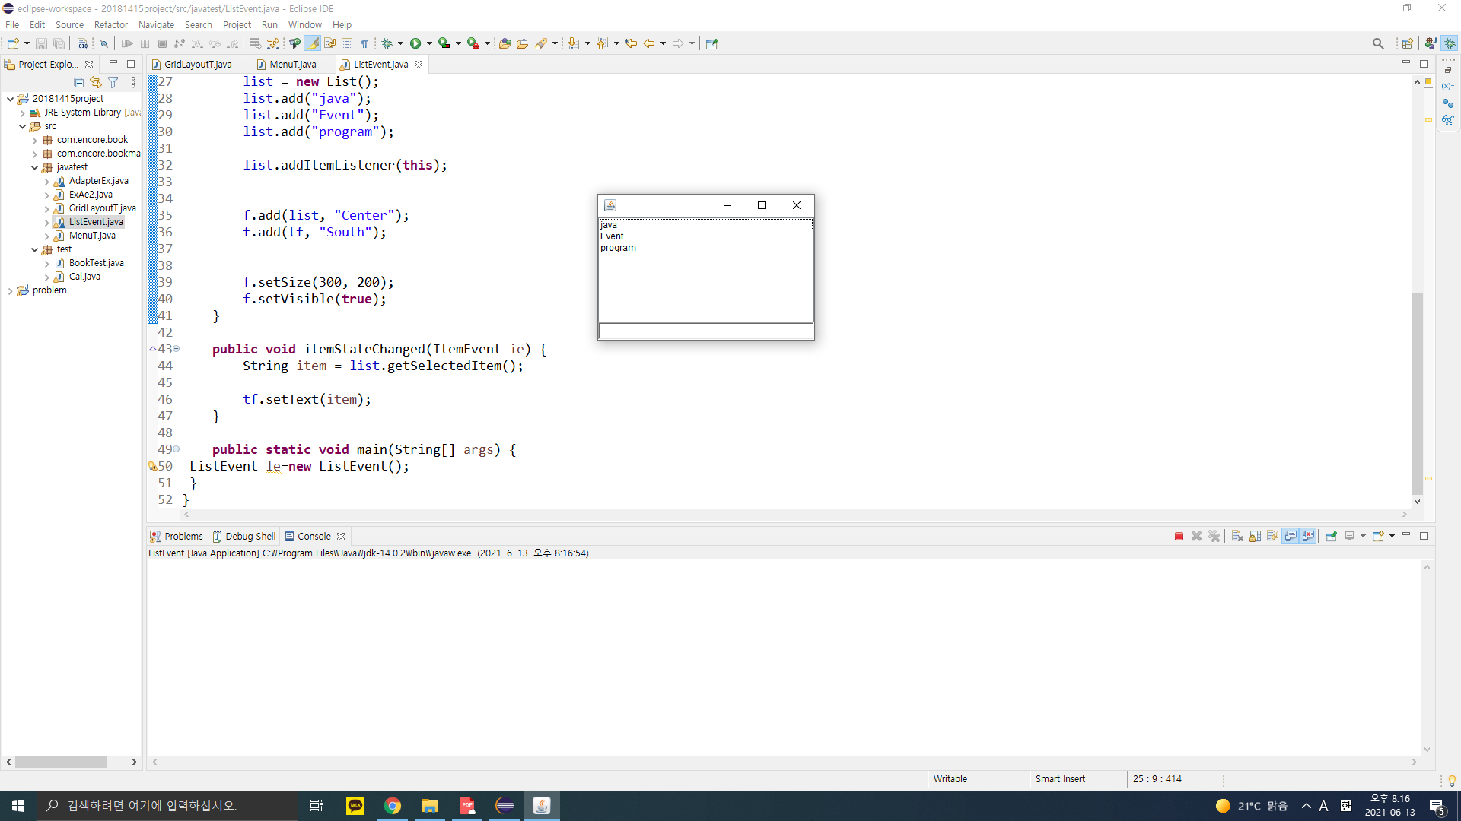

package javatest;

import java.awt.\*;

import java.awt.event.\*;

import java.awt.Label;

class ListEvent implements ItemListener {

private Frame f;

private List list;

private TextField tf;

public ListEvent() {

f = new Frame();

f.addWindowListener(new WindowAdapter() {

public void windowClosing(WindowEvent we) {

System.exit(0);

}

});

tf = new TextField(20);

list = new List();

list.add("java");

list.add("Event");

list.add("program");

list.addItemListener(this);

f.add(list, "Center");

f.add(tf, "South");

f.setSize(300, 200);

f.setVisible(true);

}

public void itemStateChanged(ItemEvent ie) {

String item = list.getSelectedItem();

tf.setText(item);

}

public static void main(String[] args) {

ListEvent le=new ListEvent();

}

}